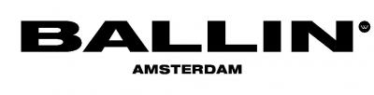

Your information
First name: | Surname:
Ordernumber: __ __ __ __ __ | Invoice number: INV__ __ __ __ __
Address:
Postcode: | City:
Country:
Phone: | Mobile phone:
IBAN:
E-mail:
Remarks:

Date:
Signature:

Fill in as applicable:
Exchange good
Returned product: | Exchange for product: | Size: | Reason of exchange:

Return good
Returned product: | Make your choice: | Reason of return:
 | Refund purchase amount /*Coupon code
 | Refund purchase amount /*Coupon code
 | Refund purchase amount /*Coupon code

Please note: If you want to exchange your product, please send an e-mail to info@ballinamsterdam.com in advance of your return, in order to make sure we will have the product of your wish in stock for you.

*Coupon code: If you choose this option, you will receive a coupon code to the valuation of the purchase amount of your product which you can use for another order on our website.

Further information concerning returns
After receipt of your product you can return it within 14 days. You will receive the full amount of purchase, however the costs of the return shipment will be for your own account. If you want to make use of this right you will have to return the product in its original state to us. Please keep in mind we can not process your return if the product has been used or is damaged, if the label is detached or if your return has been sent later than 14 days after receipt.

Address
BALLIN Amsterdam
Postbus 77
1620AB Hoorn
info@ballinamsterdam.com
+ 31 6 81 59 00 59

