ACCESSOIRE ROUE SKI ROUE SKATE

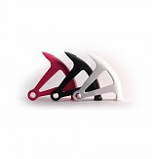
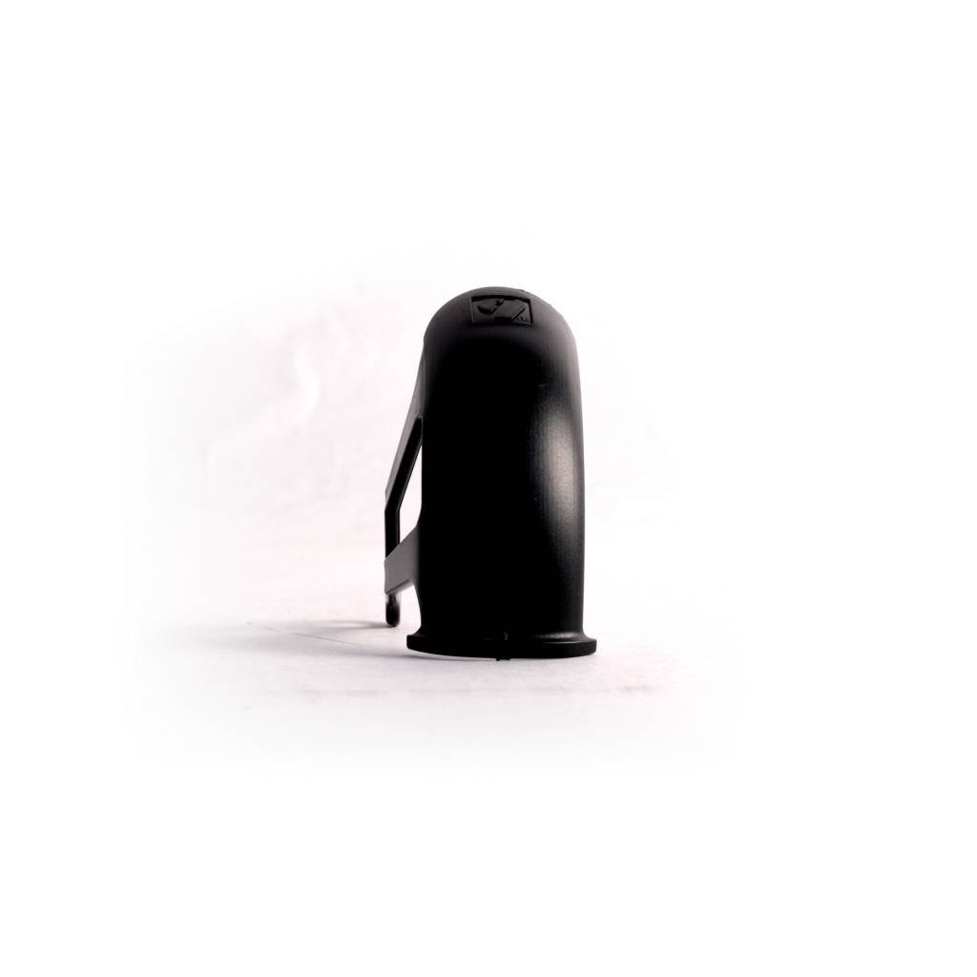
Garde-boue Skating

Les garde-boues pour ski-roues skating sont universelles.
Installé par nos soins, ils garantissent la protection des éventuelles salissures et éclaboussure causé lors de vos entraînement.
Léger et solide, ils sont indispensables pour un entraînement optimal ne dépendant plus des conditions climatiques.

Caractéristiques techniques:

- PU
- Poids (la paire): 100 g
- Vendus par paire

