ACCESSOIRE BATONS

XS-01 Dragonnes ajustables

Dragonne pour bâtons de ski nordique.
Idéale pour la pratique du biathlon puisqu’elle s’enlève et s’enfile facilement et rapidement.
Très résistante et confortable, cette dragonne accompagne vos mouvements à la perfection sans aucun gène occasionné.
Réglable et ajustable

11,5 g
Circonférence total : 54 cm

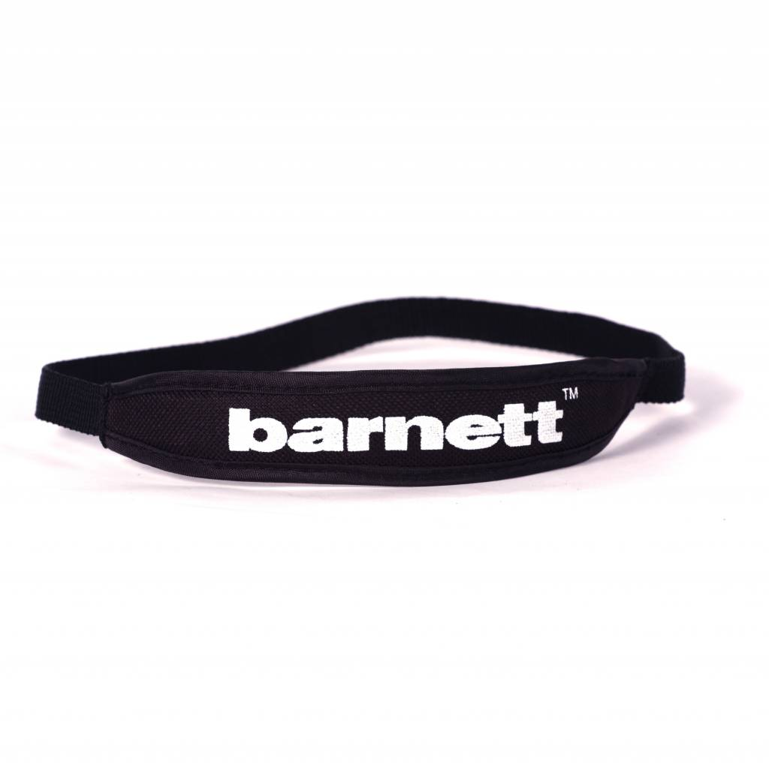
Epaisseur 3,3 cm
Epaisseur 1 cm

