BATTE SOFTBALL
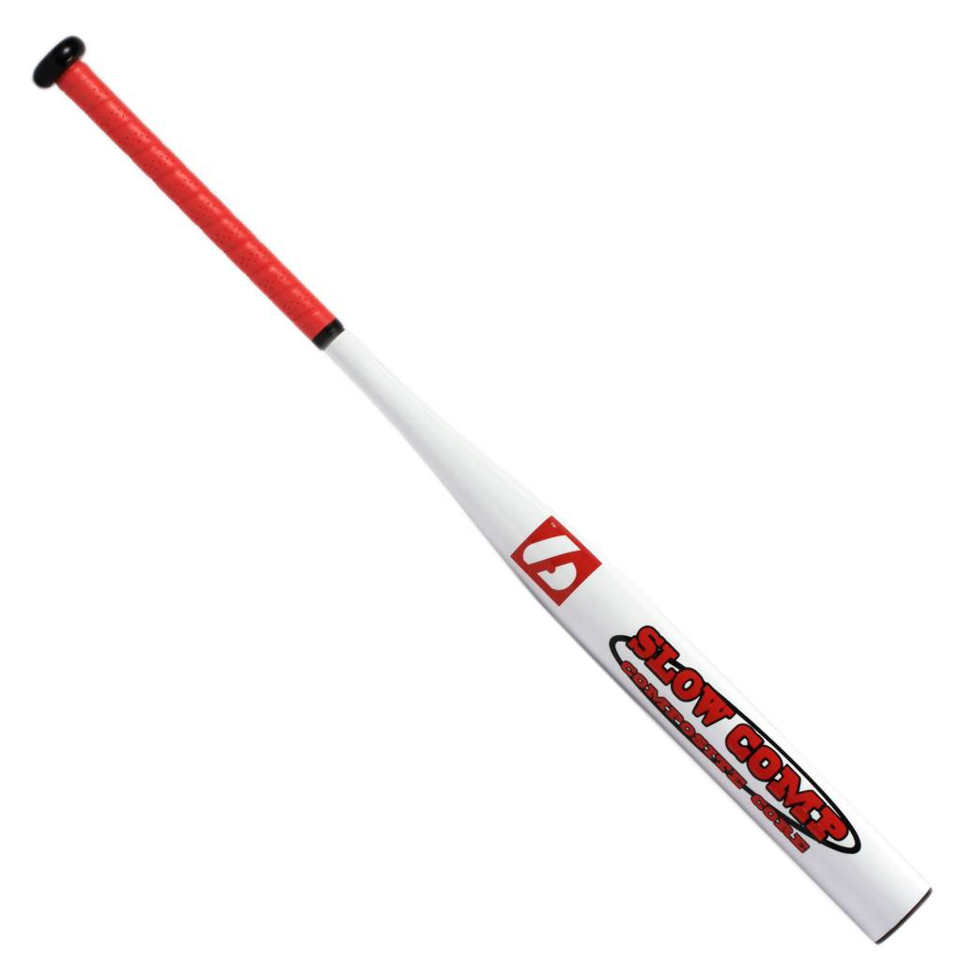
SLOW-COMP

Batte en aluminium composite X830
Résistante avec une prise de main agréable grâce à un grip de haute qualité.
L’esthétisme et une excellente maniabilité sont réunis autour d’un bois de qualité.
Idéal pour entraînements et compétition.

Données techniques :

57 mm diamètre
21,5 mm handle

Longueur :
- 34" (86,36 cm)

Ratio :
- -8
- A noter : plus le ratio est élevé, plus la batte seras maniable

Couleur : Blanc
Poids :
- 33" : 25 oz
- équivalent à 935 g

