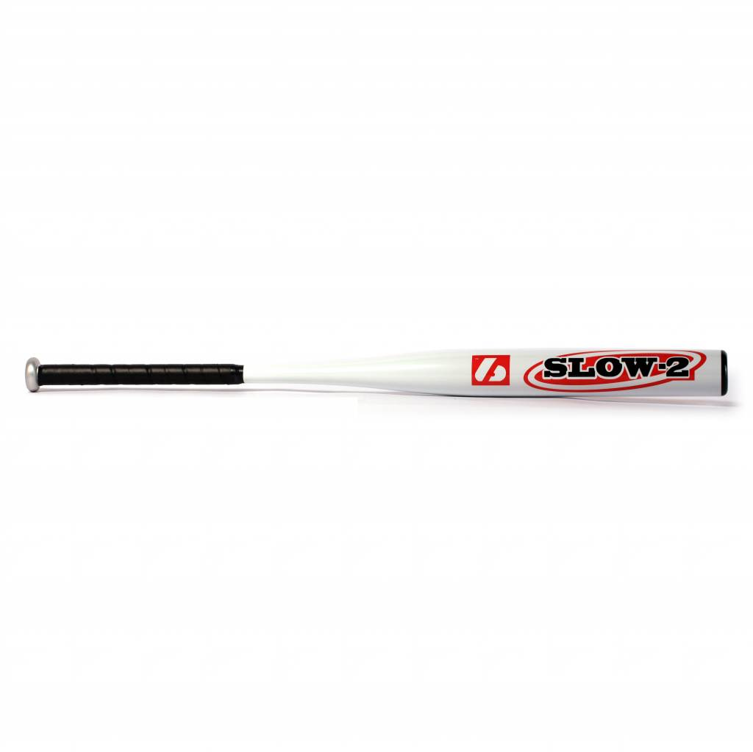

BATTE SOFTBALL

SLOW 2

Batte en aluminium 7046.
Résistante et prise de main agréable grâce à un grip de haute qualité.
Idéale pour les compétitions de haut niveau.

Données techniques :

57 mm diamètre
21,5 handle

Longueur :
- 34" (86,36 cm)
- 36’’ (91,44 cm)

Ratio :
- -6
- A noter : plus le ratio est élevé, plus la batte seras maniable

Couleur : Blanc
Poids :
- 34" : 28 oz (963 g)
- 36’’ : 30 oz (1020 g)

