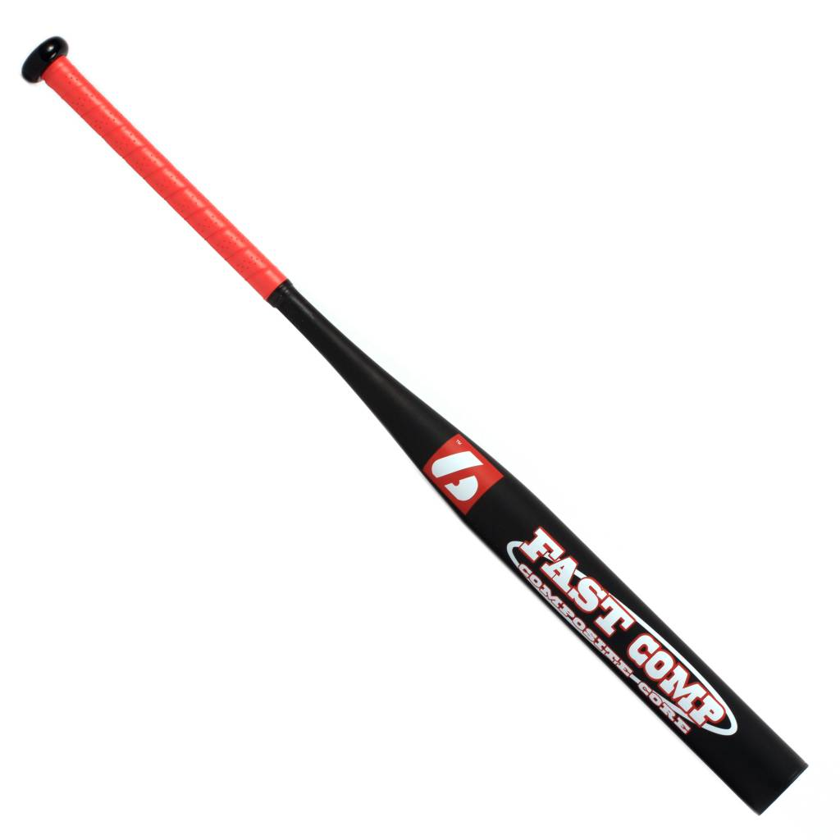

BATTE SOFTBALL

FAST-COMP

Batte en alluminium X830
Résistante et prise en main agréable avec un grip de haute qualité.
Contient du composite noir qui participe à un excellent rendu et amortis les vibrations.
Idéale pour les compétitions de haut niveau.

Données techniques :

57 mm diamètre
21,5 mm handle

Longueur :
- 33" (83,82 cm)
- 34’’ ( 86,36)

Ratio :
- -12
- A noter : plus le ratio est élevé, plus la batte seras maniable

Couleur : Noir et grip rouge
Poids :
- 33" : 21 oz (595g)
- 34’’ : 24 oz (680 g)

