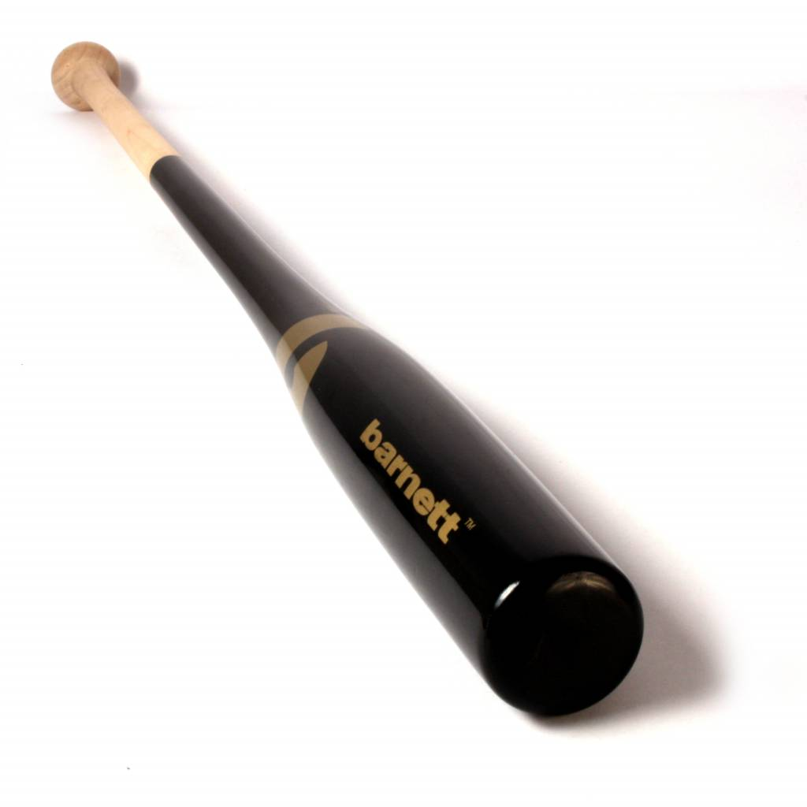
BATTE BASEBALL

BF-B noir

Poids :
- 35 " : 22 oz (696g)
Batte en bois composite et bambou beige et noir.
Esthétique et très résistante, cette batte est idéale pour l’entraînement.
Fine et légère, elle assure une tenue en main agréable et confortable pour un usage optimal.

Données techniques :

Longueur :
- 35" (88,9 cm)

Ratio :
- – 13
- A noter : plus le ratio est élevé, plus la batte seras maniable

Couleur : Noir

