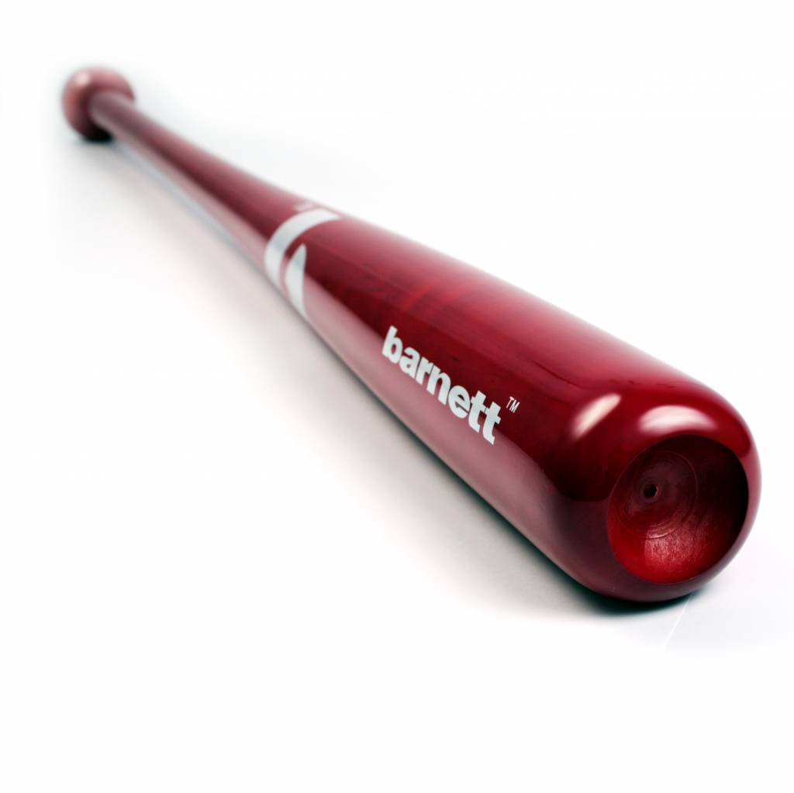
BATTE BASEBALL

BB-8

Poids :
- 32 " : 29 oz (795,5 g)
- 33" : 30 oz (817 g)
- 34" : 31 oz (842 g)

Batte en bois d’érable, modèle 62, très résistante avec une prise en main agréable.
Idéale pour les entraînements et les matchs.
Batte très puissante avec un excellent rendement.

Données techniques :

Longueur :
- 32" (81,28 cm)
- 33" (83,82 cm)
- 34" (86,36 cm)

Ratio :
- -3
- A noter : plus le ratio est élevé, plus la batte seras maniable

Couleur : Rouge

