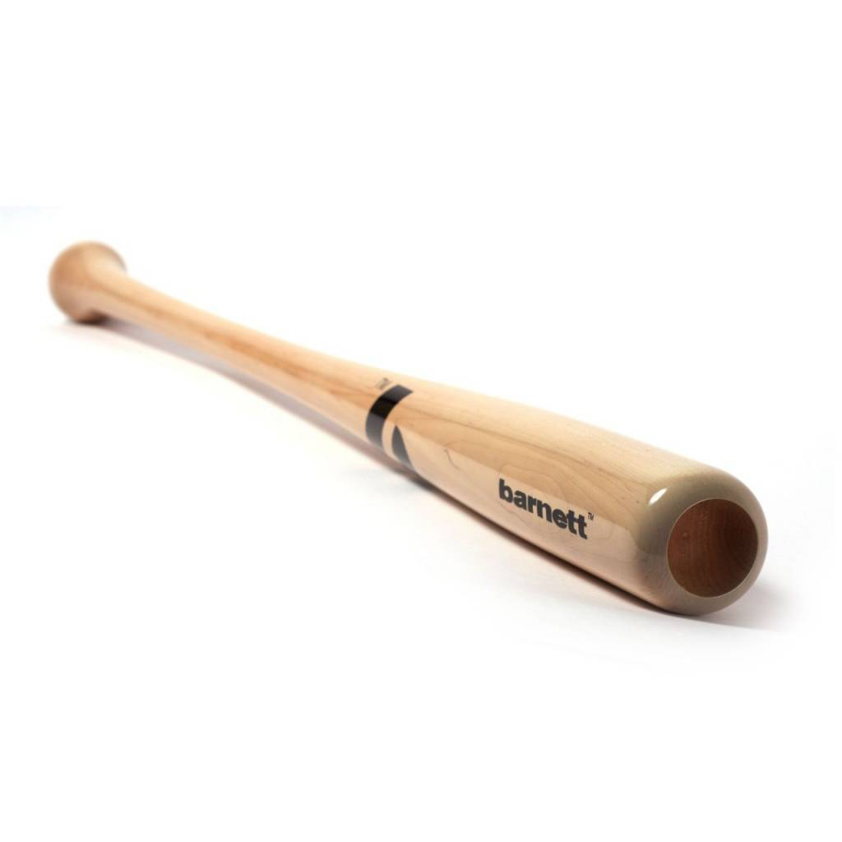

BATTE BASEBALL

BB-6

Poids :
- 32 " : 28 oz (856,5 g)
- 33" : 29 oz (883,2 g)
- 34" : 30 oz (910 g)

Batte en bois d’érable, modèle 210, pour la compétition de haut niveau.
Excellent rendu et amorti des vibrations.
Haute qualité avec du bois d’Erable contenant une haute résistance professionnelle.

Données techniques :

Longueur :
- 32" (81,28 cm)
- 33" (83,82 cm)
- 34" (86,36 cm)

Ratio :
- -4
- A noter : plus le ratio est élevé, plus la batte seras maniable

Couleur : Bois naturel

