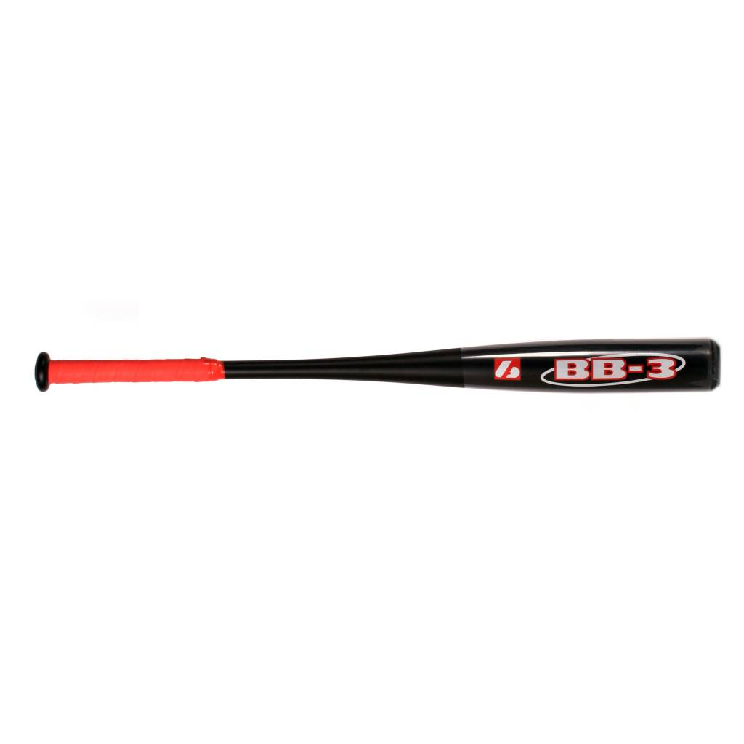

BATTE BASEBALL

BB-3

Batte en aluminium, modèle 7050 très résistante, prise en main très agréable grâce à un grip haute qualité.
Idéale pour les compétitions de haut niveau.
Batte très puissante avec un excellent rendement.

Données techniques :

Longueur :
- 32" (81,28 cm)
- 33" (83,82 cm)
- 34" (86,36 cm)

Ratio :
- – 1
- A noter : plus le ratio est élevé, plus la batte est maniable

Couleur : Noire / Rouge

Poids :
- 32 " : 30 oz (849,5 g)
- 33" : 31 oz (878 g)
- 34" : 32 oz (906 g)

