CLASSIC RCE-ENTRY

RSE-­‐ENTRY are roller-­‐ski skating made for people who want to improve. They are available in two different sizes : the largest size for adults, and the smallest for kids.

RCE-­‐ENTRY 700 ADULT |  | Price :
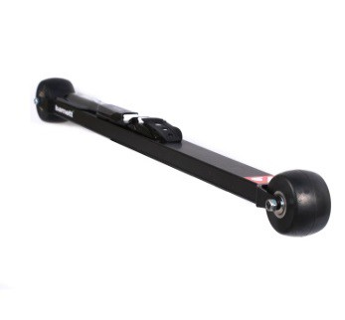 | Product specification :  Roller ski RCR-­‐RACE Adult are perfect for training and competition. Their low profile format allows you to feel as if skiing on snow. The aluminium frame offers lightness and resistance to the roller-­‐ski. The propulsion is made easier thanks to no moving back wheels. The frame length and highly resistant monoblock forks also ensure stable trajectories and important reduction vibrations.  Sold by pair with wheels and bindings.
Technical characteristics :

Frame: alloy Aluminium 7075
Weight (one ski with wheels : 1088g) (+ binding : 137,75g )
Length: 2' 3" 9/16 (700mm) axle to axle
Forks: Monoblocks, alloy Aluminium 7075
Clearance frame-ground: 1" 1/8 (29mm)
Clearance skiboot-ground: 2" 5/16 (58mm) (bindings Salomon), 2" 5/8 (67mm) (bindings
Rottefella)
Wheels: PU 76 35, 3" x 1" 9/16 (76x40mm)
Bearings: ABEC 9 Waterproof
Bindings: to choose
Bindings available :
- Salomon SNS pilot Equipe Classic
- Salomon SNS Prolink Equipe Classic
- Salomon SNS Pilot Sport Classic
- Salomon SNS Propulse RC
- Rottefella NNN Xcelerator
Warning : Bindings Salomon are adaptable only with SNS standard skiboots, and Rottefella bindings are adaptable only with NNN standard skiboots.
www.barnettsports.com

