SKATING RSE-ENTRY

RSE-­‐ENTRY are roller-­‐ski skating made for people who want to improve. They are available in three different sizes. You will find in this document all informations you need to choose the most adapted to your level and what you are looking for.

RSE-­‐ENTRY 610 |  |  | Price :
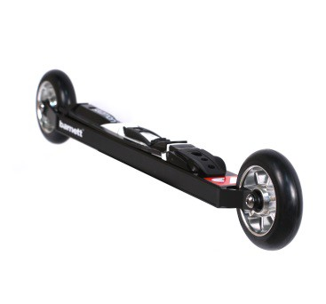 | Product specification :  Roller-­‐ski RSE-­‐ENTRY were developed for people who want to improve their technical skills on roller ski. They were made for light-­‐weight and powerful skiers. This initiation and training product has an aluminium frame offering lightness and resistance. It gives beginners a steady and comfortable ski to make them improve easily. Sold by pair with wheels and bindings.
Technical characteristics :

Frame: alloy Aluminium 6061
Weight (one ski with wheels): 1203,75 g (+ bindings : 137,75)
Length: 2' 0" (610mm) axle to axle
Forks: Monoblocks, alloy Aluminium 6061
Clearance frame-ground: 1" 1/8 (29mm)
Clearance skiboot-ground: 2" 1/4 (57mm) (bindings Salomon), 2" 5/8 (66mm) (bindings Rottefella)
Wheels: 3" 15/16 x 0" 15/16 (100x24mm) ; hardness (speed) to choose
Bearings: ABEC 9 Waterproof
Bindings: to choose
Wheels available :  -­‐ USP Competition : 74-­‐50 slow (pink) ; 76-­‐50 slow (yellow) ; 78-­‐50 slow (orange) ; 80-­‐50 medium (green) ; medium 82-­‐50 (red) (price +40)  -­‐ USE : 76-­‐35 slow ; 76-­‐50 slow ; 82-­‐50 medium ; 89-­‐50 fast  The first number indicates the hardness/resistance of wheels. The second one shows the rebound/elasticity of wheels. The combination of these two values gives the speed of the wheels (slow : 10-­‐35 km/h ;  medium : 15-­‐40 km/h ; fast : 15-­‐50 km/h) |  | Bindings available :  -Salomon SNS pilot Equipe Skate  - Salomon SNS Prolink Skate  -­‐ Salomon SNS Pilot Sport Skate  -­‐ Salomon SNS Pilot Carbon RS Skate (price +10)  -­‐ Salomon SNS Pilot Carbon RS2 Skate (price +10)  -­‐ Rottefella NNN Xcelerator  Warning : Bindings Salomon are adaptable only with SNS standard skiboots, and Rottefella bindings are adaptable only with NNN standard skiboots.

www.barnettsports.com

RSE-­‐ENTRY 530 |  |  | Price :
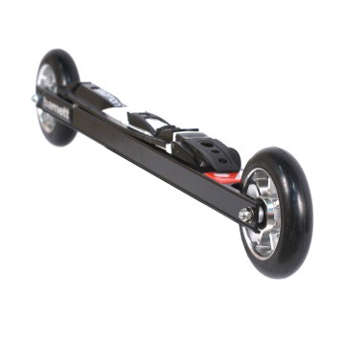 | Product specification :  Roller-­‐ski RSE-­‐ENTRY were developed for people who want to improve their technical skills on roller ski. This initiation and training product has an aluminium frame offering lightness and resistance. It gives beginners a steady and comfortable ski to make them improve easily. Sold by pair with wheels and bindings.
Technical characteristics :

Frame: alloy Aluminium 6061
Weight (one ski with wheels) : 1217,5 g (+ binding : 137,75)
Length: 1' 8" 7/8 (530mm) axle to axle
Forks: screwed, alloy Aluminium 6061
Clearance frame-ground: 1" 9/16 (39mm)
Clearance skiboot-ground: 2" 5/8 (67mm) (bindings Salomon), 3" (76mm) (bindings Rottefella)
Wheels: 3" 15/16 x 0" 15/16 (100x24mm) ; hardness (speed) to choose
Bearings: ABEC 9 Waterproof
Bindings: to choose
Wheels available :  -­‐ USP Competition : 74-­‐50 slow (pink) ; 76-­‐50 slow (yellow) ; 78-­‐50 slow (orange) ; 80-­‐50 medium (green) ; medium 82-­‐50 (red) (price +40)  -­‐ USE : 76-­‐35 slow ; 76-­‐50 slow ; 82-­‐50 medium ; 89-­‐50 fast  The first number indicates the hardness/resistance of wheels. The second one shows the rebound/elasticity of wheels. The combination of these two values gives the speed of the wheels (slow : 10-­‐35 km/h ; medium : 15-­‐ 40 km/h ; fast : 15-­‐50 km/h) |  | Bindings available :  -Salomon SNS pilot Equipe Skate  -Salomon SNS Prolink Skate  -­‐ Salomon SNS Pilot Sport Skate  -­‐ Salomon SNS Pilot Carbon RS Skate (price +10)  -­‐ Salomon SNS Pilot Carbon RS2 Skate (price  +10)  -­‐ Rottefella NNN Xcelerator  Warning : Bindings Salomon are adaptable only with SNS standard skiboots, and Rottefella bindings are adaptable only with NNN standard skiboots.
www.barnettsports.com

