MAILLOT MANCHE LONGUE COMPRESSION

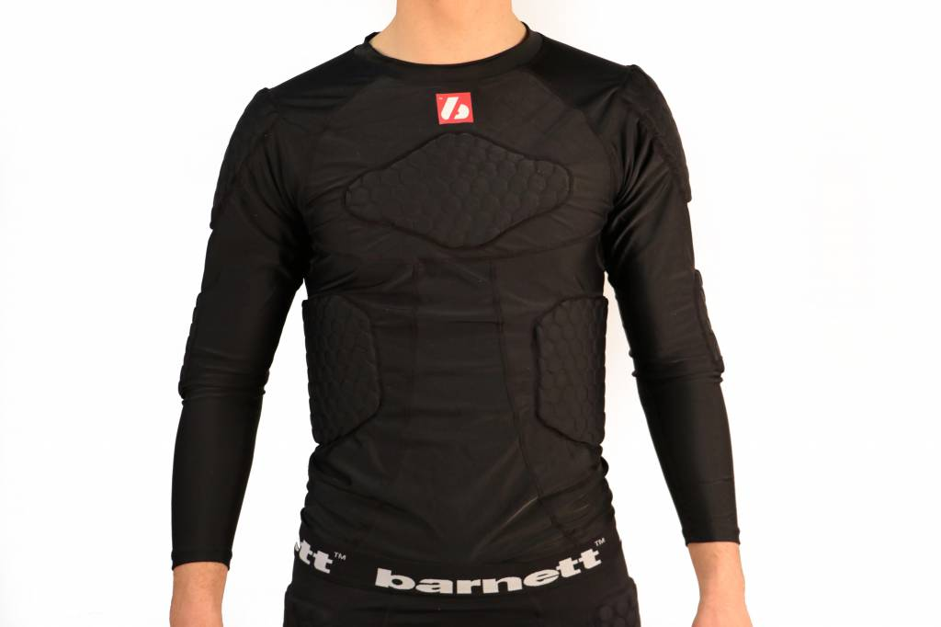
FS-08
Nouvelle génération de protections. Pratique, ce maillot intègre directement les protections. A utiliser aussi bien en entraînement qu'en match.

5 pièces intégrées assurant la protection des différentes parties du buste :
- Protection des côtes
- Protection des épaules
- Protection du sternum
- Protection des coudes
- Protection du bas du dos

- Couleur disponible : Noir
http://www.barnett.fr/fs-08-maillot-de-compression-5-pieces-integrees.html

 | Chest width | Lenght center back | Shoulder on the top | Arm hole | Shoulder on side
 | A | B | C | D | E
S | 52 | 56 | 68 | 23 | 12
M | 54 | 57 | 69 | 24 | 13
L | 56 | 59 | 71 | 25 | 14
XL | 58 | 60 | 73 | 26 | 16
2XL | 60 | 60 | 74 | 27 | 18
3XL | 62 | 63 | 79 | 28 | 20
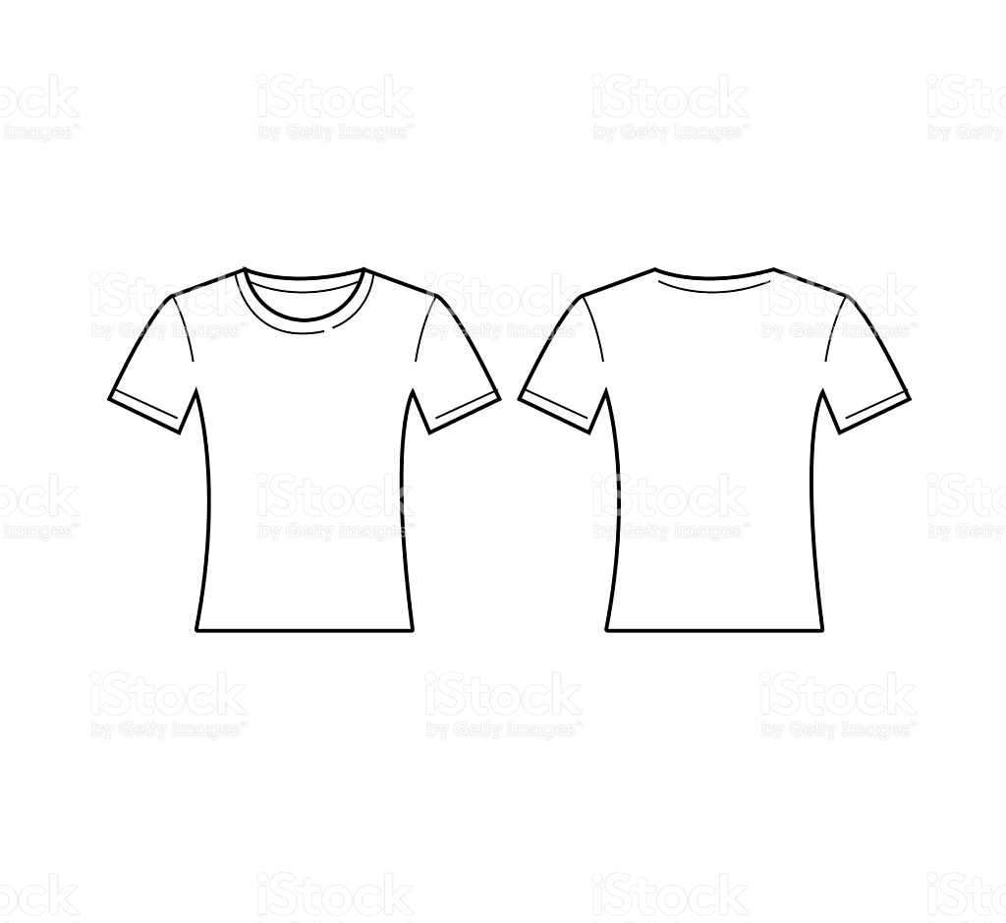
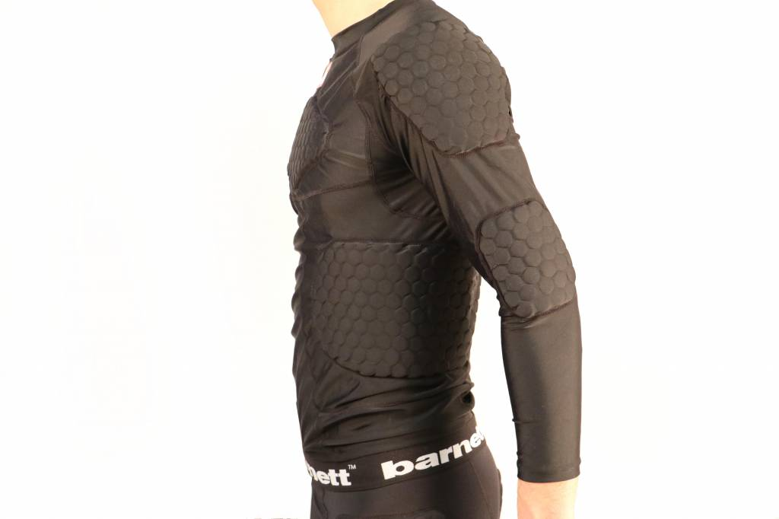
A
EA
D
B
C

