PANTALON DE COMPRESSION FOOTBALL AMERICAIN

FS-07
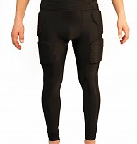
- Compression: Coupe ultra-serrée seconde peau
- Souple et résistant, accompagne chacun de vos mouvements pour une activité physique optimale
- Pratique, ce pantalon intègre directement les protections.
5 pièces intégrées assurant la protection des différentes parties du corps :
- Protection du coccyx
- Protection des cuisses
- Protection des hanches

- 100% Polyester/Elastane
- Coloris disponible : Noir

http://www.barnett.fr/fs-07-pantalon-de-compression-5-pieces-integrees.html

 | A | B | C | D
S | 33 | 80 | 19 | 20
M | 35 | 82,5 | 20 | 21
L | 38 | 85 | 21 | 23
XL | 40 | 86,5 | 22 | 25
2XL | 41,5 | 88 | 22,5 | 29
3XL | 44 | 91 | 24 | 31
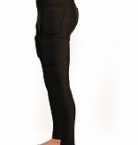
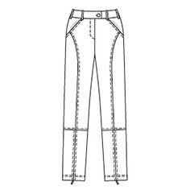
A
C
B
D

