BATTE BASEBALL

BB-PINK

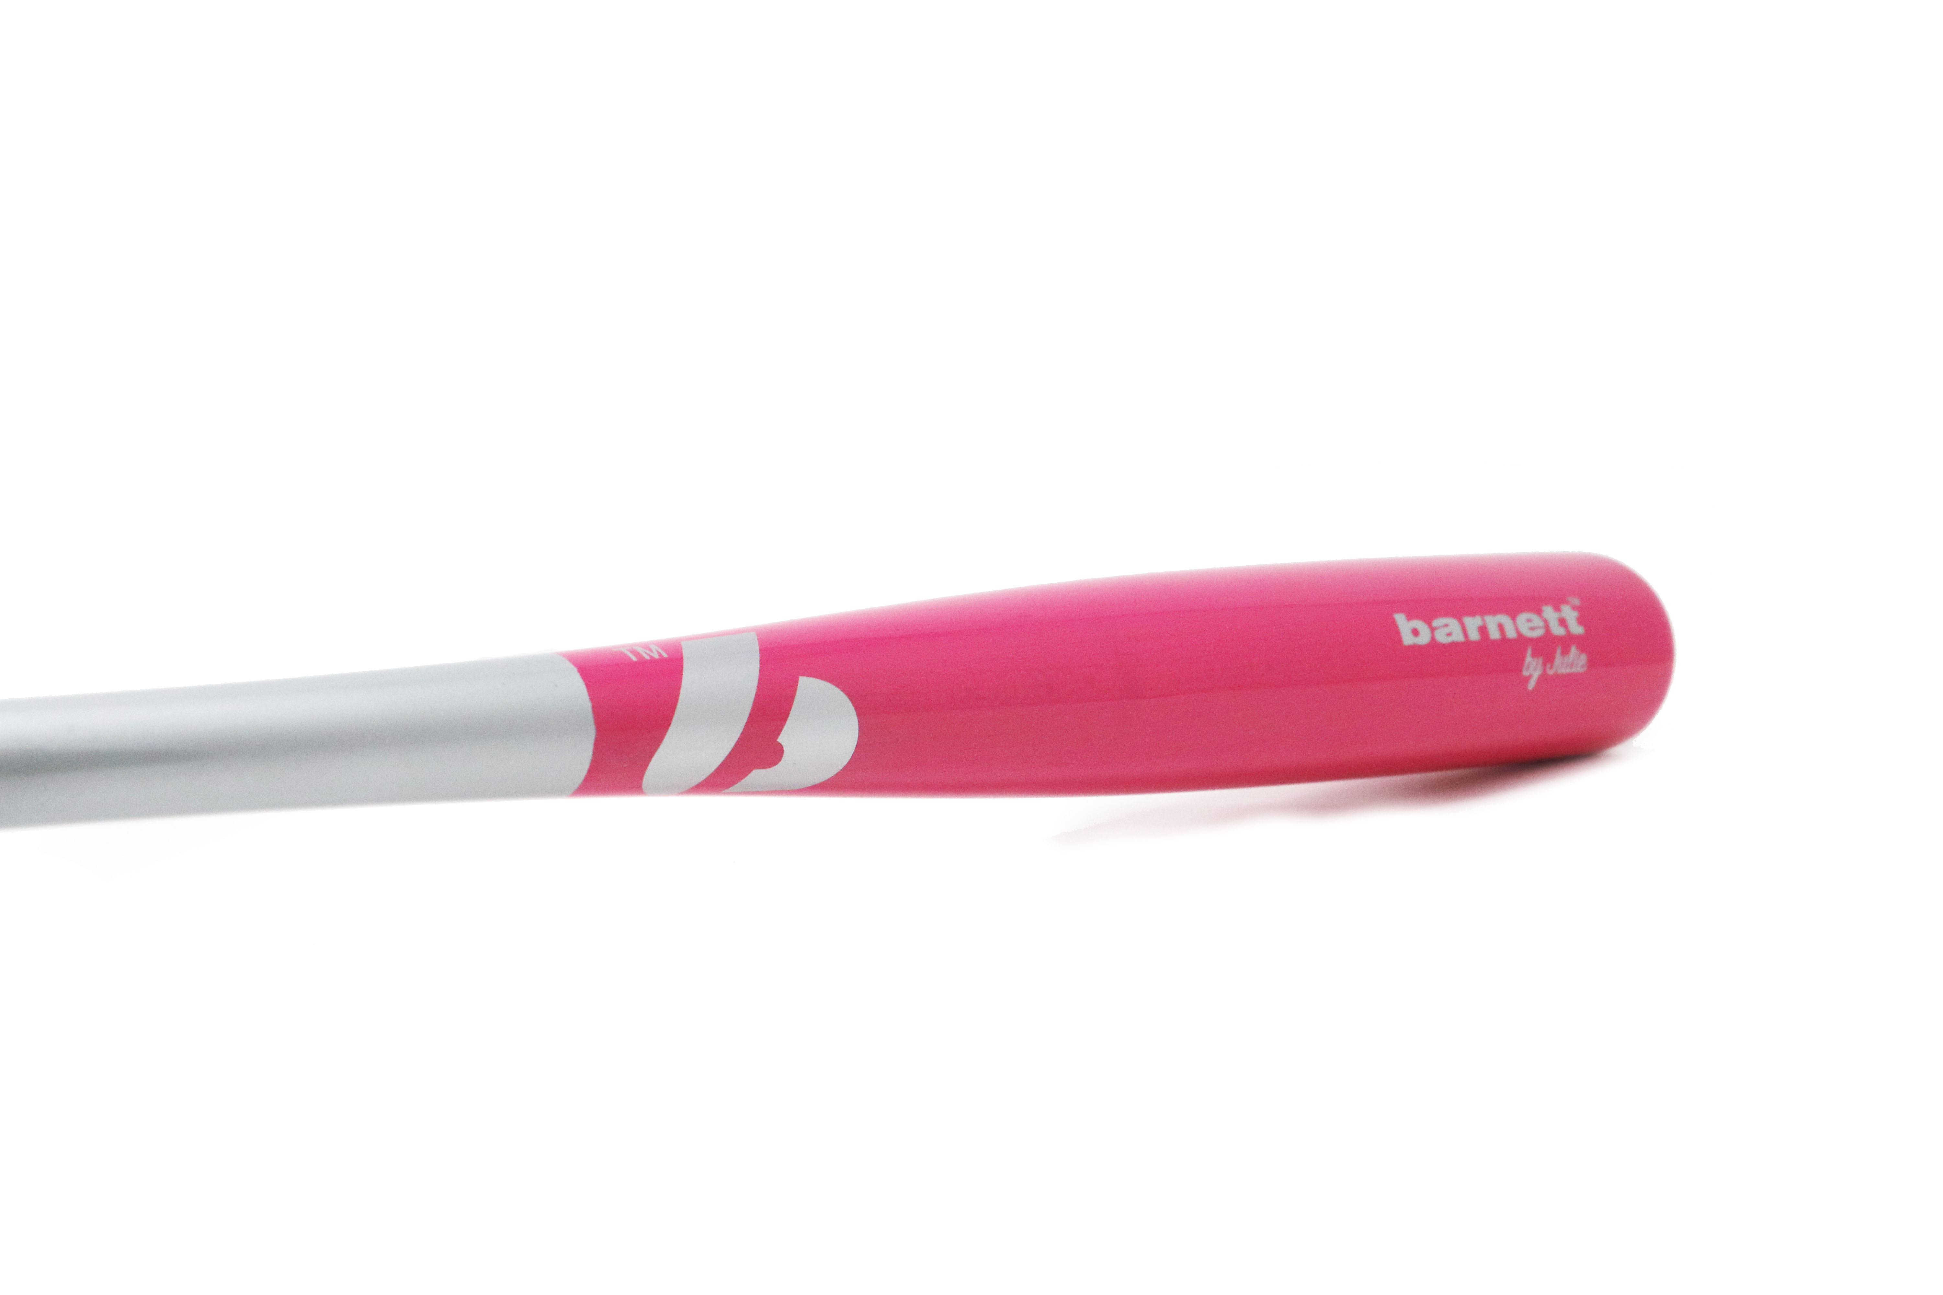

Batte pour l'entrainement et la compétition de haut niveau, excellent rendu et amorti des vibrations.
Bois haute qualité. Haute résistance.
33"-30 oz

Données techniques :

Longueur :
- 33" (83,82 cm)

Ratio :
- -3
- A noter : plus le ratio est élevé, plus la batte seras maniable

Couleur : Gris irisé et rose
Poids :
- 33" : 30 oz
- équivalent à 933g

