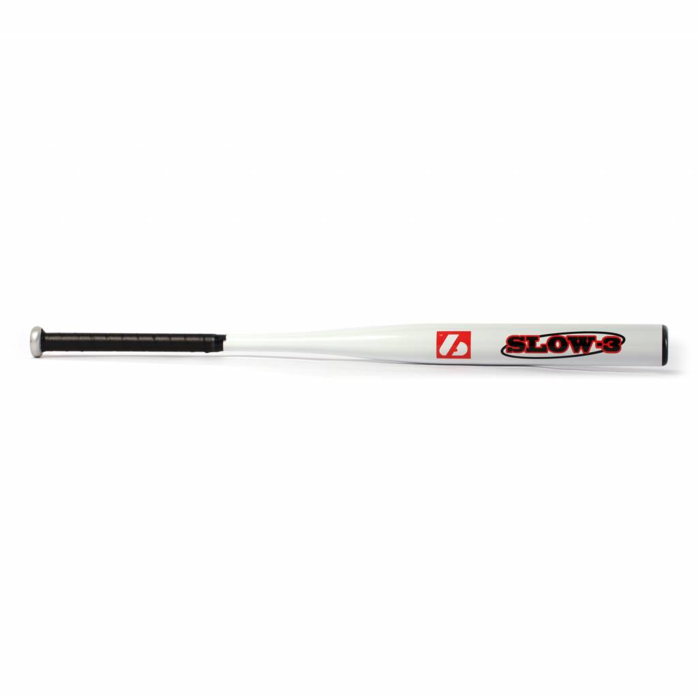

BATTE SOFTBALL

SLOW 3

Poids :
- 34" : 23 oz
- 38’’ : 26 oz

Batte en aluminium X830.
Résistante et prise de main agréable grâce à un grip de haute qualité.
Idéale pour les compétitions de haut niveau.

Données techniques :

57 mm diamètre
21,5 handle

Longueur :
- 34" (86,36 cm)
- 38’’ (91,44 cm)

Ratio :
- -11
- A noter : plus le ratio est élevé, plus la batte seras maniable

Couleur : Blanc

