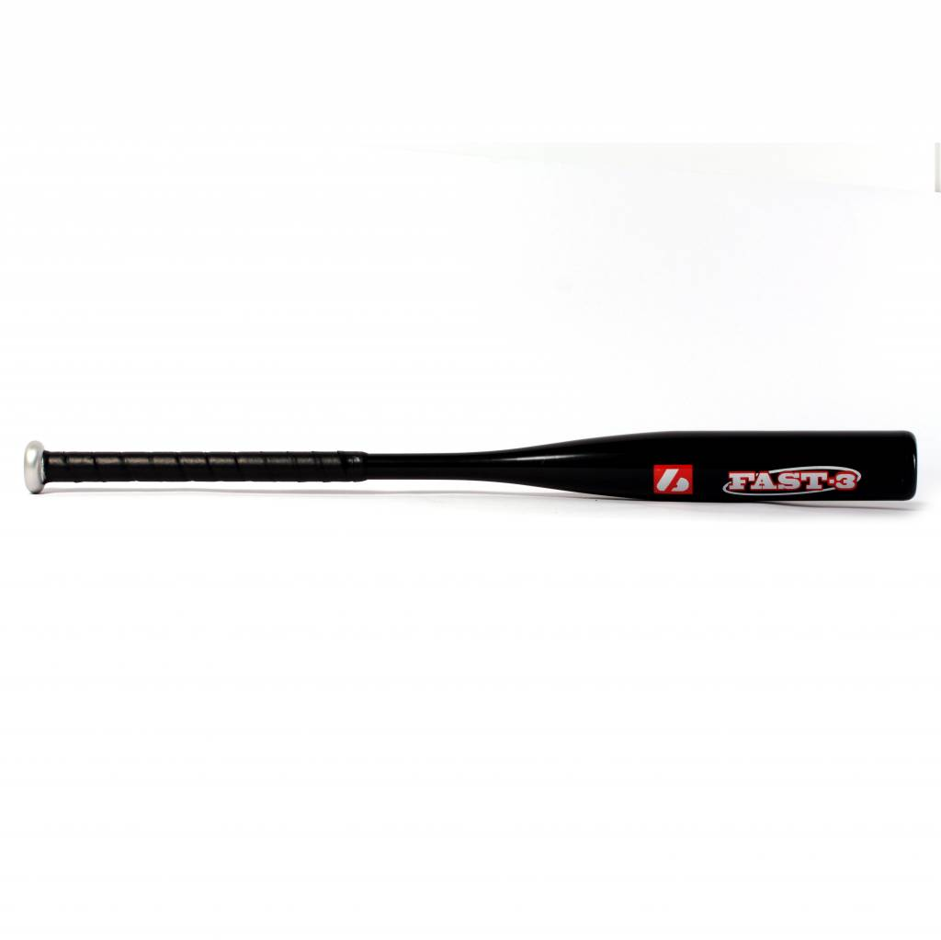

BATTE SOFTBALL

FAST 3

Batte en alluminium X830.
Résistante et agréable avec un grip de haute qualité.
Idéale pour les compétitions de haut niveau.
Excellent rendu et amortis des vibrations.

Données techniques :

57 mm diamètre
21,5 mm handle

Longueur :
- 34" (86,36 cm)

Ratio :
- -3
- A noter : plus le ratio est élevé, plus la batte seras maniable

Couleur : Rouge et Blanche
Poids :
- 34" : 22 oz
- équivalent à 623 g

