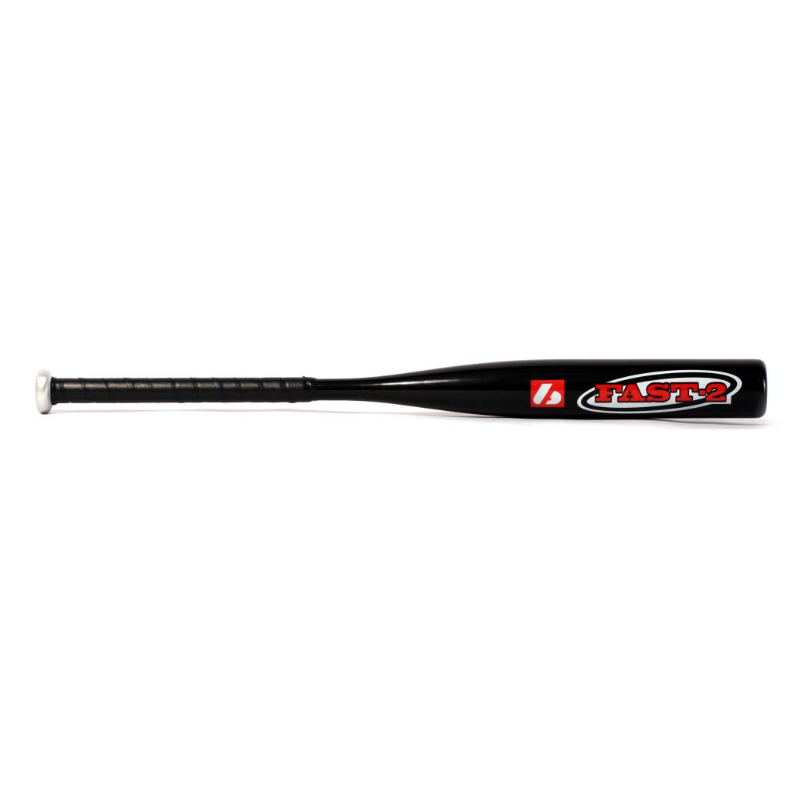

BATTE SOFTBALL

FAST 2

Poids :
- 33" : 21 oz (595 g)
- 34’’ : 23 oz (964 g)

Batte en alluminium 7050.
Résistante et prise en main agréable grâce à un grip de haute qualité.
Idéale pour les entraînements et en compétitions.

Données techniques :

57 mm diamètre
21,5 mm handle

Longueur :
- 33" (83,82 cm)
- 34’’ (86,36 cm)

Ratio :
- -12
- A noter : plus le ratio est élevé, plus la batte seras maniable

Couleur : Noir

