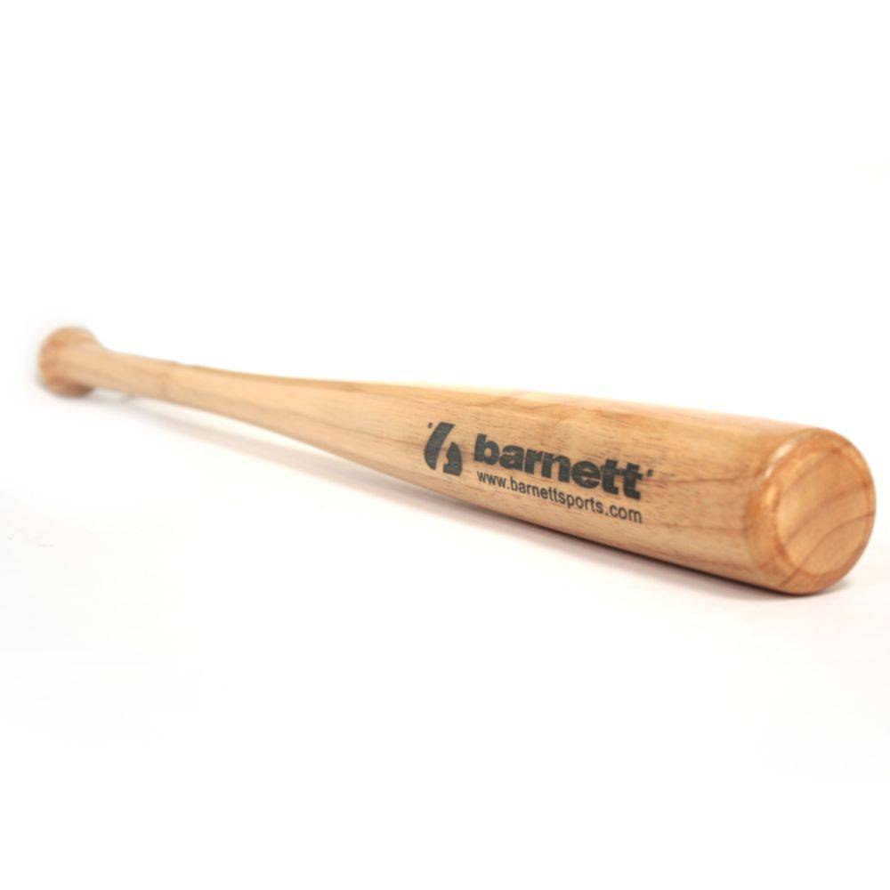

BATTE BASEBALL

BB-W

Batte de découverte en bois composite à utiliser avec une balle molle.
ATTENTION : La BB-W est une batte d'initiation et de loisir.
Ce n'est pas une batte de match ou d'entrainement.

Sa structure et son poids permet de frapper la balle plus facilement qu'avec une batte en aluminium mais avec moins de puissance, ce qui est idéale pour apprendre le baseball ou le pratiquer en loisir.

Données techniques :

Longueur :
- 25" (63,5 cm)
- 28" (71,12 cm)
- 30" (76,2 cm)
- 32’’ (81,28 cm)
Ratio :
- -2
- A noter : plus le ratio est élevé, plus la batte seras maniable

Couleur : Bois naturel
Poids :
- 25 " : 27 oz (462 g)
- 28" : 30 oz (560 g)
- 30" : 32 oz (565,5 g)
- 32’’ : 34 oz (630,5g)

