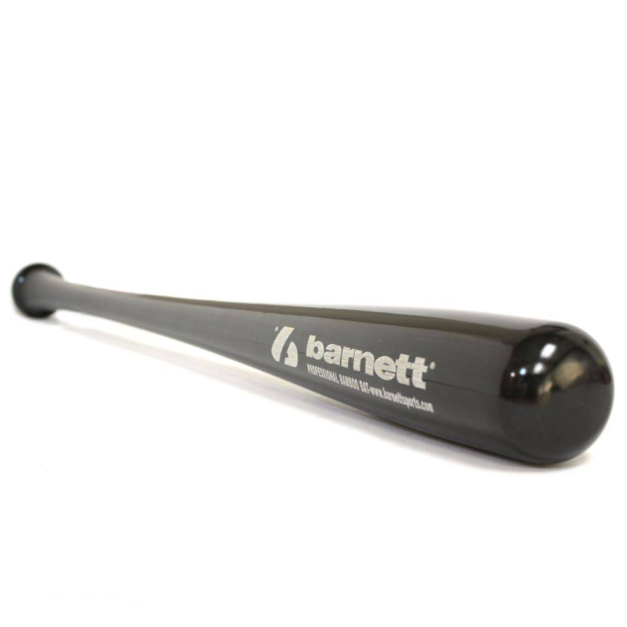

BATTE BASEBALL

BB-10

Batte en bois d’érable d’excellente qualité.
Haute résistance pro, modèle 2104.
Batte pour la compétition de haut niveau avec un excellent rendu et amorti des vibrations.

Données techniques :

Longueur :
- 32" (81,28 cm)
- 33" (83,82 cm)
- 34" (86,36 cm)

Ratio :
- -4
- A noter : plus le ratio est élevé, plus la batte seras maniable

Couleur : Noire
Poids :
- 32 " : 28 oz (807 g)
- 33" : 29 oz (832,2 g)
- 34" : 30 oz (857,4 g)

