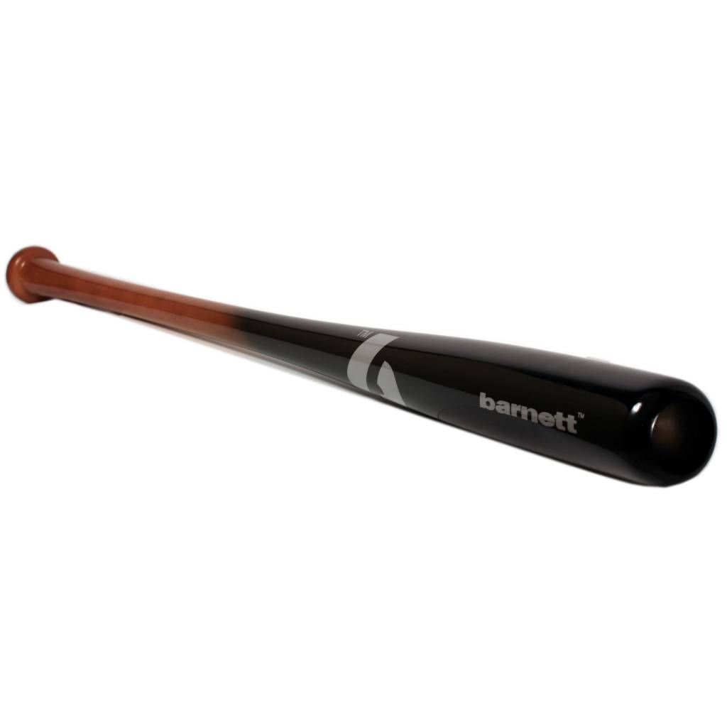

BATTE BASEBALL

BB-7

Batte en bois d’érable, modèle 110 pour compétitions de haut niveau. Excellent rendu et amorti des vibrations.
Haute résistance professionnelle grâce à un bois d’excellente qualité.

Données techniques :

Longueur :
- 32" (81,28 cm)
- 33" (83,82 cm)
- 34" (86,36 cm)

Ratio :
- – 7
- A noter : plus le ratio est élevé, plus la batte seras maniable

Couleur : Noire
Poids :
- 32 " : 25 oz (881 g)
- 33" : 26 oz (908,5 g)
- 34" : 27 oz (936 g)

