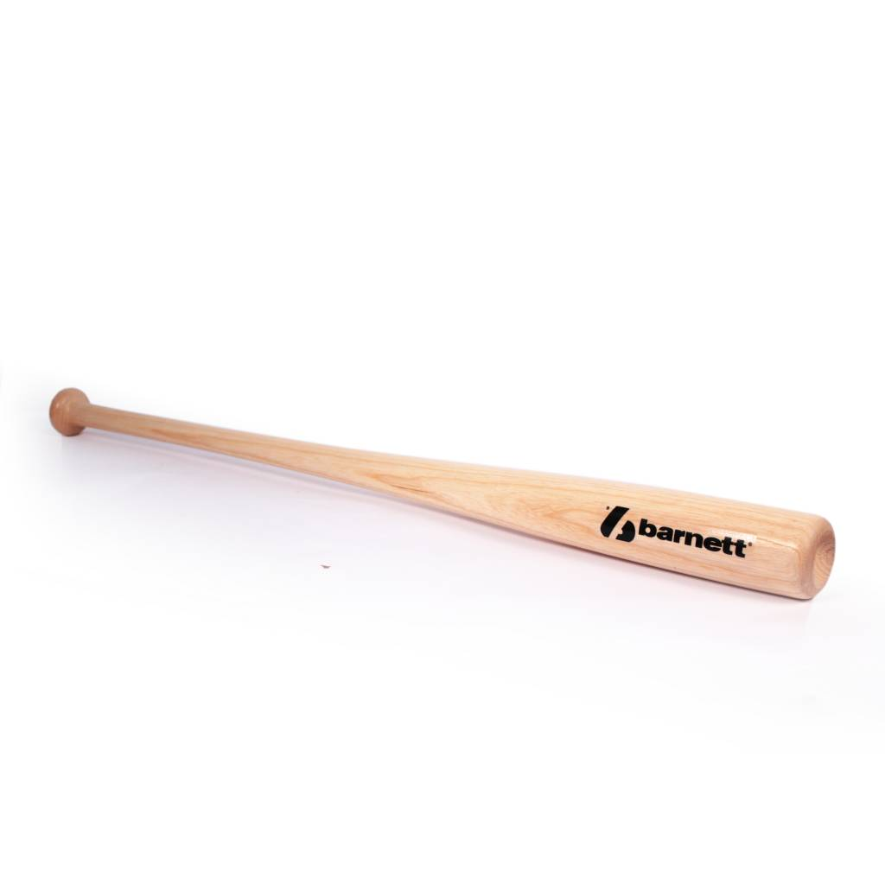

BATTE BASEBALL

BB-5

Batte en bois de bambou et d’érable, modèle 433, pour la compétition de haut niveau.
Excellent rendu et amorti des vibrations.
Bois de haute qualité ayant une grande résistance.

Données techniques :

Longueur :
- 32" (81,28 cm)
- 33" (83,82 cm)
- 34" (86,36 cm)

Ratio :
- – 3
- A noter : plus le ratio est élevé, plus la batte seras maniable

Couleur : Bois naturel

Poids :
- 32 " : 29 oz (810 g)
- 33" : 30 oz (835,3 g)
- 34" : 31 oz (860,6 g)

