CLASSIC RCC-CARBON

RCC-­‐CARBON are high-­‐range roller-­‐ski for classic style. They are available in two different sizes : the largest size for adults, and the smallest for kids.

RCC-CARBON 700 ADULT |  | Price :
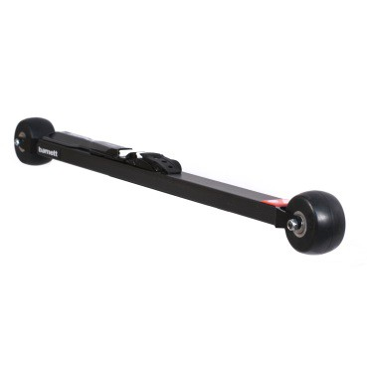 | Product specification :  Roller ski RCC-­‐CARBON Adult are perfect for training and high-­‐level competition. Their low profile format allows you to feel as if skiing on snow. The carbon frame guarantees an unequalled lightness and a very good stiffness for a better energy transmission to the roller-­‐ski. The propulsion is made easier thanks to no moving back wheels. Roller ski length and highly resistant monoblock forks also ensure stable trajectories and important reduction of vibrations.  Sold by pair with wheels and bindings.
Technical characteristics :

Frame: 100% carbon
Weight (one ski with wheels ): 761g (+ bindings : 137,75g )
Length: 2' 4" 3/4 (730mm) axle to axle
Forks: Monoblocks, alloy Aluminium 7075
Clearance frame-ground: 1" 1/8 (29mm)
Clearance skiboot-ground: 2" 1/4 (57mm) (bindings Salomon), 2" 5/8 (66mm) (bindings
Rottefella)
Wheels: PU 76 35, 3" x 1" 9/16 (76x40mm)
Bearings: ABEC 9 Waterproof
Bindings: to choose
Bindings available :
-­‐Salomon SNS pilot Equipe Classic
-­‐Salomon SNS Prolink Classic
-­‐Salomon SNS Pilot Sport Classic
-­‐Salomon SNS Propulse RC
-­‐Rottefella NNN Xcelerator
Warning : Bindings Salomon are adaptable only with SNS standard skiboots, and Rottefella bindings are adaptable only with NNN standard skiboots.
www.barnettsports.com

