SKATING RS-530 Initiation

RS-530 Initiation |  |  | Price :
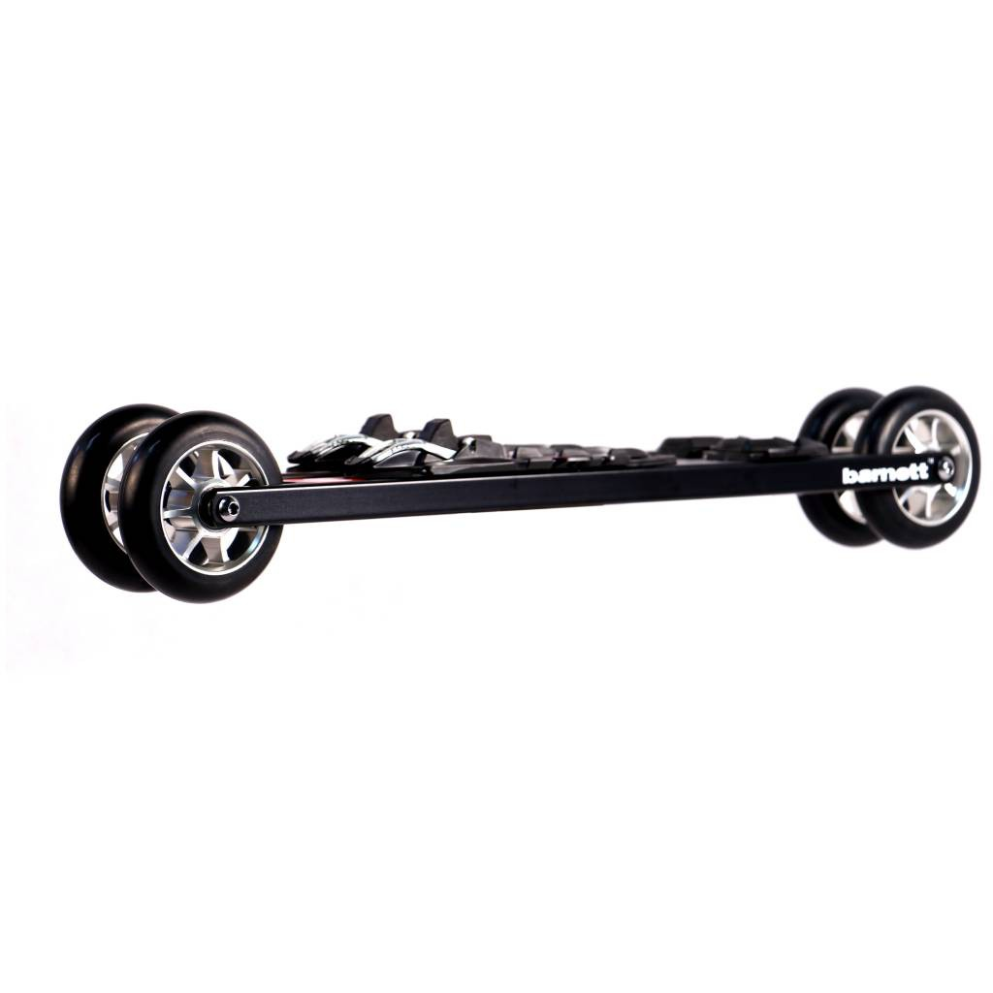 | Product specification :  Roller ski RS-530 Initiation were developed for people who want to improve their technical skills on roller ski. This initiation and training product has an aluminium  frame offering lightness and resistance. Supplies to the beginner a stable and comfortable ski to acquire some experience by himself.  Sold by pair with wheels and bindings.  Each model is personalized for customers
Technical characteristics :

Frame: alloy Aluminium 6061
Weight (one ski with wheels): 1504,75g (+ bindings : 137,75g)
Length: 1' 8" 7/8 (530mm) axle to axle
Forks: screwed, alloy Aluminium 6061
Clearance frame-ground: 1" 9/16 (39mm)
Clearance skiboot-ground: 2" 15/16 (59mm) (bindings Salomon), 2" 11/16 (68mm)
(bindings Rottefella)
Wheels: 3" 15/16 x 0" 15/16 (100x24m) ; hardness (speed) to choose
Bearings: ABEC 9 Waterproof
Bindings: to choose
Wheels available :  -­‐ USP Competition : 74-­‐50 slow (pink) ; 76-­‐50 slow (yellow) ; 78-­‐50 slow (orange) ; 80-­‐50 medium (green) ; medium 82-­‐50 (red) (price +40)  -­‐ USE : 76-­‐35 slow ; 76-­‐50 slow ; 82-­‐50 medium ; 89-­‐50 fast  The first number indicates the hardness/resistance of wheels. The second one shows the rebound/elasticity of wheels. The combination of these two values gives the speed of the wheels (slow : 10-­‐35 km/h ;  medium : 15-­‐40 km/h ; fast : 15-­‐50 km/h) |  | Bindings available :  -Salomon SNS pilot Equipe Skate  -Salomon SNS Prolink Skate  -­‐ Salomon SNS Pilot Sport Skate  -­‐ Salomon SNS Pilot Carbon RS Skate (price +10)  -­‐ Salomon SNS Pilot Carbon RS2 Skate (price +10)  -­‐ Rottefella NNN Xcelerator  Warning : Bindings Salomon are adaptable only with SNS standard skiboots, and Rottefella bindings are adaptable only with NNN standard skiboots.
www.barnettsports.com

