SKATING RSR-RACE

RSR-­‐RACE are high-­‐quality roller-­‐ski skating. They are available in three different sizes. You will find in this document all informations you need to choose the most adapted to your level and what you are looking for.

RSR-RACE 610 |  |  | Price :
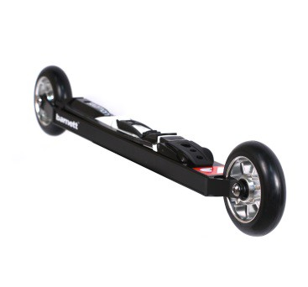 | Product specification :  Roller-­‐ski RSR-­‐RACE were developed for skiers looking for performance during training and competitions. They are specially adapted for powerful skiers. The low profile format allows you to feel as if skiing on snow. The aluminium frame offers lightness and resistance. Its length and highly resistant monoblock forks also ensure stable trajectories and good reduction of vibrations.  Sold by pair with wheels and bindings.
Technical characteristics :

Frame: alloy Aluminium 7075
Weight (one ski with wheels): 1264,75g (+ bindings : 137,75g )
Length: 2' 0" (610mm) axle to axle
Forks: Monoblocks, alloy Aluminium 7075
Clearance frame-ground: 1" 1/8 (29mm)
Clearance skiboot-ground: 2" 5/16 (59mm) (bindings Salomon), 2" 11/16 (68mm) (bindings Rottefella)
Wheels: 3" 15/16 x 0" 15/16 (100x24mm) ; hardness (speed) to choose
Bearings: ABEC 9 Waterproof
Bindings: to choose
Wheels available :  -­‐ USP Competition : 74-­‐50 slow (pink) ; 76-­‐50 slow (yellow) ; 78-­‐50 slow (orange) ; 80-­‐50 medium (green) ; medium 82-­‐50 (red) (price +40)  -­‐ USE : 76-­‐35 slow ; 76-­‐50 slow ; 82-­‐50 medium ; 89-­‐50 fast  The first number indicates the hardness/resistance of wheels. The second one shows the rebound/elasticity of wheels. The combination of these two values gives the speed of the wheels (slow : 10-­‐35 km/h ; medium : 15-­‐40 km/h ; fast : 15-­‐50 km/h) |  | Bindings available :  -Salomon SNS pilot Equipe Skate  -Salomon SNS Prolink Skate  - Salomon SNS Pilot Sport Skate  -Salomon SNS Pilot Carbon RS Skate (price +10)  -Salomon SNS Pilot Carbon RS2 Skate (price +10)  - Rottefella NNN Xcelerator  Warning : Bindings Salomon are adaptable only with SNS standard skiboots, and Rottefella bindings are adaptable only with NNN standard skiboots.
www.barnettsports.com

