MAILLOT DE FOOTBALL AMERICAIN

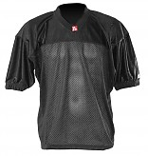
FJ-1
- Maillot d’entraînement et de match, ideal pour le flag football américain

- Léger et resistant
- 100% heavy polyester

- Couleurs disponibles : Blanc, Noir, Bleu Royal, Bleu marine, Jaune et Rouge

http://www.barnett.fr/fj-1-maillot-de-football-americain-de-flag.html

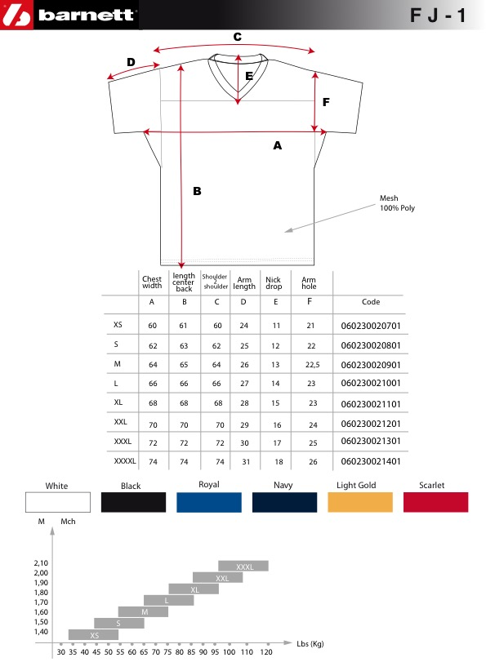

 | Chest width | Lenght center back | Shoulder on the top | Arm length | Nick drop | Arm hole | Shoulder on side
 | A | B | C | D | E | F | G
XS | 60 | 61 | 60 | 24 | 11 | 21 | 17
S | 62 | 63 | 62 | 25 | 12 | 22 | 19
M | 64 | 65 | 64 | 26 | 13 | 22,5 | 21
L | 66 | 66 | 66 | 27 | 14 | 23 | 22
XL | 68 | 68 | 68 | 28 | 15 | 23 | 23
2XL | 70 | 70 | 70 | 29 | 16 | 24 | 25
3XL | 72 | 72 | 72 | 30 | 17 | 25 | 27
4XL | 74 | 74 | 74 | 31 | 18 | 26 | 28
G

