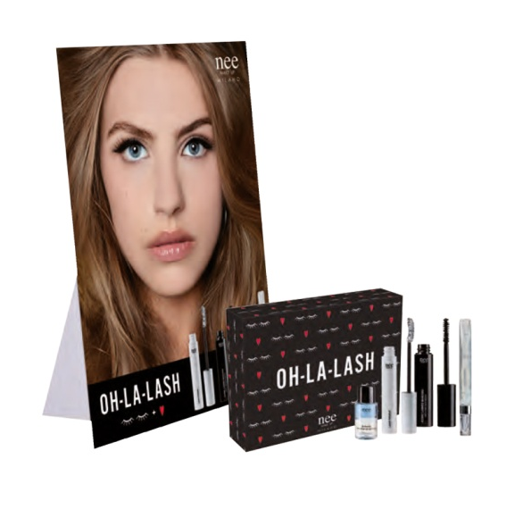
DEAL OH-LA-LASH |LIMITED EDITION|

PRODUCT |PRODUIT| |  | N° | AP |PA| | VP |PV| | TOTAAL |TOTAL|
OH LA LASH GIFT BOX | LASH PRIMER | 9 | € 11,80 | € 25,96 | AP |PA|  = € 30,24  VP |PV|  = € 60,50
 | ICONIC LASHES MASCARA |  | € 11,43 | € 25,15
 | GLOSSY LIPS 070 |  | € 9,55 | € 21,00
 | BI-PHASE EYE MAKE-UP REMOVER 20ML |  | € 3,75 | €7,50
 | LEAFLET OH LA LASH
EXCL BTW |HORS TVA| |  |  |  |  | € 272,16
OH LA LASH GIFT BOX TESTERS |99%| |  | 1 | 30,24 |  | 0,30
CARTELLO VETRINA |99%| |  | 1 | 6,00 |  | 0,06
LARGE SHOPPER|99%| |  | 10 | 0,49 |  | 0,05
PRICE LIST OH LA LASH |99%| |  | 1 | 0,30 |  | 0,00
EXCL BTW |HORS TVA| |  |  |  |  | € 272,57
INCL BTW |HORS TVA| |  |  |  |  | € 329,81

PRODUCT |PRODUIT| |  | N° | AP |PA| | VP |PV| | TOTAAL |TOTAL|
OH LA LASH GIFT BOX | LASH PRIMER | 5 | € 11,80 | € 25,96 | AP |PA|  = € 30,24  VP |PV|  = € 60,50
 | ICONIC LASHES MASCARA |  | € 11,43 | € 25,15
 | GLOSSY LIPS 070 |  | € 9,55 | € 21,00
 | BI-PHASE EYE MAKE-UP REMOVER 20ML |  | € 3,75 | €7,50
 | LEAFLET OH LA LASH
EXCL BTW |HORS TVA| |  |  |  |  | € 151,20
CARTELLO VETRINA |99%| |  | 1 | 6,00 |  | 0,06
LARGE SHOPPER|99%| |  | 5 | 2,45 |  | 0,02
PRICE LIST OH LA LASH |99%| |  | 1 | 0,30 |  | 0,00
EXCL BTW |HORS TVA| |  |  |  |  | 151,28
INCL BTW |HORS TVA| |  |  |  |  | 183,05
*NIET RETOURNEERBAAR|NON RETOURNABLE

